3

A District of Innovation

BLOCS INSTITUTE SCHEDULE

Date: Thursday, July 18 2022, 8:15-3:30 PM
Location: Cleveland High School
Audience: Administrators, instructional coaches, teachers and , teaching support staff Purpose: To gain knowledge on content based language instruction for emergent bilingual students (EB’s).
Schedule

7:30-8:15 | Check-in
8:15-9:15 | Choice Session 1
9:15-9:30 | Break
9:30-10:30 | Choice Session 2
10:30-10:45 | Break
10:45-11:45 | Choice Session 3
11:45-1:15 | LUNCH On Your Own
1:15-2:15 | Choice Session 4
2:15-2:30 | Break
2:30-3:30 | Choice Session 5

- Participants will choose 5 one hour sessions

BLOCS INSTITUTE LOGISTICS

SESSIONS: Participants will have the opportunity to choose 5 sessions. Maximum capacity per session is 25.

Doors will be open at 7:30 a.m. so participants can pick up a Welcome Back bag. Please be advised that the BLOCS program will be available digitally ONLY. A QR Code to the sessions will be provided in the Welcome Back bag and posted around the school.

Registration/Attendance: Participants will be required to complete a registration form using a QRcode by the check-in table. Attendees will also need to sign-in at each session to receive credit and attendance.

DEVICES: Bring your school issued laptop if you have one. There will also be Chromebooks available to use.

PARKING: Attendees will park in the CHS parking lot including the football and baseball field parking lots. Do not park in the reserved parking.

PLEASE DO NOT BLOCK THE FOOD TRUCK DESIGNATED AREA
NO PARKING in the bus drop off Area in the back of the CHS cafeteria.

Recommendations: Staff members are strongly encouraged to carpool as parking spaces at CHS are limited.

Front Parking Lot

ENTRANCES TO CHS CAMPUS: A door monitor will be at these locations during these times: 7:00-7:45 and 11:45-1:30 p.m.

FOOD TRUCKS: There will be 6 six food trucks available for the staff who decide to stay on campus.
The food trucks will be parked in the normal bus drop-off area located in the back of the cafeteria.

PRIZES: Drawing for prizes will take place each break session. Must be present to win. A ticket will be given at the entrance.

DRESS CODE: Professional casual dress (NO jeans)

Cleveland HIgh School Map (Downstairs)

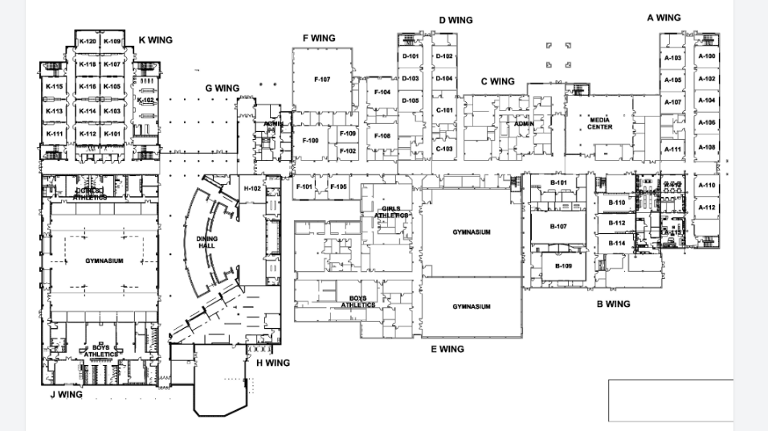
Cleveland HIgh School Map (Upstairs)

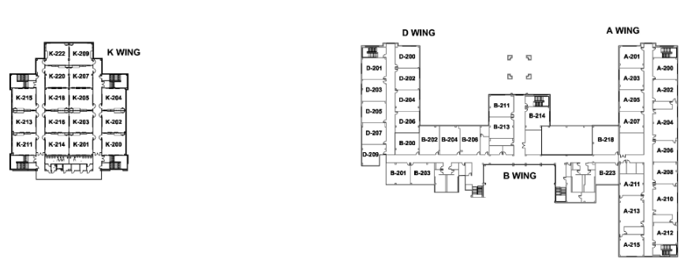

A HUGE thank you to all of our presenters for representing or supporting our district’s Emergent Bilingual Program!

General Sessions
Session | Title | Description | Focus Audience | Presenter | Room Number
All Sessions | ELPS Overview | Understanding ELPS, Integrating ELPS in planning, Incorporating ELPS in the classroom | All teachers | Angela Greer | K-101
All Sessions | 7 Steps To a Language-Rich Interactive Classroom | An overview of 7 research-based strategies to engage all learners in listening, speaking, reading, and writing. Participants will learn about and practice each of the 7 Steps as well as learn new strategies for the classroom. Great for new teachers or those who just need a quick refresher. | All teachers | Dr. Ashley Beeman | K-103
All Sessions | Accommodations and Strategies Effective for EB/Sped students | Improve knowledge of classroom accommodations that can be effective to both emergent bilingual and special education students. | All teachers | Jennifer Groce | K-105
All Sessions | Social Emotional Learning(Trauma informed Classrooms) | Participants will become familiar with how to work with the whole child. | All teachers | Dr. Tyra Hodge | K-107
All Sessions | Small Moves, Big Gains for RLA, Social Studies and Co-teach Classes | “I don't have enough time.” “I learned so many strategies at that training, but I don't have the time to plan for them.” “This strategy works well…when I remember to use it. Can you relate to any of these sentiments? If so, this training is for YOU! Small Moves, Big Gains: Teacher Habits That Help Kids to Talk More, Think More, and Achieve More offers educators a straightforward path toward increasing student outcomes. | All Teachers | Nancy McClain | K-109
All Sessions | Creating Your INSTRUCTIONAL TOOL KIT for EB Learners in your Classroom presented by Brandon Buchanan | An In Depth Tool Kit to help Teachers Be Successful with EB Learners | All Teachers | Brandon Buchanan | K-111
All Sessions | EB support in Lumio/Smart | How to use Lumio and SMART Notebook in the classroom to provide EB students with linguistic accommodations. | All Teachers | Brandy Ward | K-112
All Sessions | EB support in Discovery Education | How to navigate Discovery Education tools to help emergent bilingual students. | All Teachers | Mallori Howington | K-113
All Sessions | Snap&Read STAAR Testing | Snap&Read and Co Writer Accessibility tools(make a connection to STAAR accessibility and designated supports)(EL designated supports- extra time, oral administrations, content and language support (online visual pictures/synonyms/simplifies) and NOT translation)translation for direction. | 3-12 | Tad Traylor | K-114
All Sessions | Classroom Management Strategies: Maximizing EL Engagement & Motivation | A book written by Lora Beth Escalante which provides activities to keep students motivated in the classroom. Classroom management skills will be incorporated in the session. | All Teachers | Sandy Rivas | K-115
All Sessions | Let's TALK About It: Talk, Read, Talk, Write | The presentation will follow the 5E lesson model and will include how to incorporate talking and how to set the time for it throughout the lesson. Attendees will be asked to participate in group discussions, write using academic language, and summarize what they have read. All while collaborating and talking with others in their assigned groups. | All Audience | Pedro Venegas | K-116
All Sessions | Understanding TELPAS: Applying Strategies | Participants will gain an understanding of how each level of proficiency looks like, and what students need to be considered AH in domains such Speaking. Then, participants will have a chance to have hands on and see for themselves on cambium different types of questions students can encounter. | All Teachers | Teresa Luna & Noreen Aponte | K-118

Elementary
Session | Title | Description | Focus Audience | Presenter | Room Number
All Sessions | EB activities with an iPad in Keynote audio responses | Discover how classroom iPads can become a valuable tool in Emergent Bilingual Classrooms! 1. Interactive activities: Create interactivities for iPads that can help students learn new vocabulary and grammar concepts in both languages. | PreK-2 | Tonya Cates & Matt Tomaselli | K-120
All Sessions | Math by the Book: Teaching Mathematics Through Children's Literature | This presentation will show you how the stories are linked to important mathematical concepts, and then how those concepts are explored more deeply using the context of the stories. | K-2 Math | Wendy Benefield | K-200
All Sessions | 3 Reads for Math Problem-Solving | Modeling the CISD's 3 Reads strategy for Math Problem-Solving, while incorporating the 7 Steps to a Language-Rich Environment. | 3-5 Math | Ashley Ricketts | K-201
Sessions 1,2 and 3 | Content Based Language Instruction | Participants will review the Content-Based Language Instruction (CBLI) approach and identify the differences with the traditional sheltered instruction approach. | Prek-5 | Chandra Torres, Dr. Yacovonato Consultant | K-202
All Sessions | ELPS and their alignment to TEKS, PLDs, and TELPAS. | Participants will learn how to view Emergent Bilinguals’ speaking and writing proficiencies from an asset-based perspective to determine what EBs can do in academic tasks in English. | K-5 | Rachel Clarke, Dr. Yacovonato Consultant | K-203
All Sessions | Making Content Culturally Relevant: Focus on Elementary Classrooms | In this workshop, participants will discuss how to make content culturally relevant by using Culturally and Linguistically Sustaining Practices (CLSP). | Prek-5 | Dr. Laurie Weaver, Dr. Yacovonato Consultant | K-204
All Sessions | Stations as Easy as 123 | Participants will learn how to implement workstations successfully; and how to assess students during workstations. | PreK-5 | Lorranec Johnson | K-205
All Sessions | STEM-sational opportunities | How to incorporate the use of STEM into instruction and how STEM grows the imagination muscles in our brains. While incorporating 7 steps and TELPAS domains. | PreK-5 | Bobbie Rodriguez | K-207
All Sessions | Classroom Management with Financial Literacy | I will be applying financial literacy to classroom management. Students earn money for good behavior/following expectations and classroom jobs. They utilize a banking system, pay fines when expectations aren't met, learn how taxes and paychecks work, learn how to budget for bills & spending money on classroom prizes. | 3-5 Math | Melanie Rowland | K-209

Secondary
Session | Title | Description | Focus Audience | Presenter | Room Number
Session 1 and 2 | Vocabulary Strategies in Social Studies | This session will explore the many different ways you can teach vocabulary in social studies. | Social Studies Teachers | Kathleen Geraghty, Consultant | K-211
Session 3 and 4 | Anchor Charts in Secondary Social Studies - A Make & Take Session | This session will explore the many different ways anchor charts can benefit you in secondary social studies | Social Studies Teachers | Kathleen Geraghty, Consultant | K-211
Session 5 | Active Notes: Building Notes Around Social Studies Skills | This session will explore the many different ways embed Social Studies skills into your note-making | Social Studies Teachers | Kathleen Geraghty, Consultant | K-211
All Sessions | Word Walls and Anchor Charts in Secondary Classrooms | This session will explore characteristics of good anchor charts and word walls and will provide a glimpse of how to utilize them in the classroom. | Secondary Teachers | Carla Rogers | K-213
All Sessions | Sshh!!! Let the students talk | This session will showcase a variety of discourse strategies that can easily be adapted to any topic for any content to get students speaking, moving & interacting with each other. | Secondary Teachers | Krystal Mitchell | K-214
All Sessions | Brain Boosters | Using the best-selling book Brain Based Strategies by brain expert Eric Jensen to explore the key features of brain-based teaching on how the brain learns. Teachers will learn new concepts of brain-compatible learning and will leave with at least one lesson activity using music or a game they can use in their classroom. | Secondary Teachers | Patricia Crawford | K-215
Session 4 and 5 | Content Based Language Instruction | Participants will review the Content-Based Language Instruction (CBLI) approach and identify the differences with the traditional sheltered instruction approach. | Secondary Teachers | Chandra Torres, Dr. Yacovonato Consultant | K-202
Session 1 and 2 | English Academic Vocabulary Instruction for Emergent Bilinguals in Secondary Math Classrooms | Participants will recognize and analyze categories of academic vocabulary found in mathematics texts and word problems and learn research-based strategies to develop such vocabulary in a math classroom. | Math Teachers | Brenda Lynch, Dr. Yacovonato Consultant | K-216
Session 3 and 4 | English Academic Vocabulary Instruction for Emergent Bilinguals in High School Science Classrooms | Participants will recognize and analyze categories of academic vocabulary found in science texts and learn research-based strategies to develop such vocabulary in a science classroom. | High School Science | Brenda Lynch, Dr. Yacovonato Consultant | K-216
Session 5 | English Academic Vocabulary Instruction for Emergent Bilinguals in High School Social Studies Classrooms | Participants will recognize and analyze categories of academic vocabulary found in social studies texts and learn research-based strategies to develop such vocabulary in a social studies classroom. | High School Social Studies | Brenda Lynch, Dr. Yacovonato Consultant | K-216
All Sessions | QSSSA in Math | Participants will learn more about this approach for structuring conversations that can be used in any secondary math classroom. | Secondary Math | Lesli Serrano | K-218

